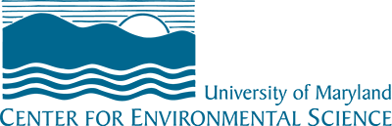 Facilities Renewal Project Request
Facilities Administration

This form is to be used for Facilities Renewal Fund request for all UMCES labs and organizations. The Facilities Renewal Fund exists for the repair and rehabilitation of the existing State-Owned facilities for its operations.

INFORMATION
Requestor:
Lab:
Phone:
Email:

PROJECT INFORMATION
PROJECT NAME:
FISCAL YEAR: | FY18
PROJECT PRIORITY:
(Provide a numeric value with 1 being the highest priority project. There should be only 1 project associated with a numeric number.)

BUILDING NAME/
BUILDING NUMBER/
SITE LOCATION:

PROJECT DESCRIPTION:
PROJECT TIME LINE:
PROJECT ESTIMATE ($):
(please attach any supporting project estimate break down if available)
PROJECT ASSESMENT
In what way is the current condition inadequate for the lab need?
Have temporary arrangements been made to mitigate existing deficiencies/problems? If so, please explain:
What are the benefits (financial, programmatic, etc.) that will occur as a result of having your request granted?

If this request is denied, what will be the consequences? What are the contingency plans for not being able to utilize Facilities Renewal funds for this project (in order to support other more pressing projects)?
Please add any other comments and attach any supporting documents for this request. Please attach existing conditions photo.
Upon completion of this form, all materials should be forwarded to the Director of Facilities Administration for review. This request and supplemental material will be reviewed with the requestor by the Director of Facilities Administration and will then be forwarded, with recommendations, to the VP for Administration for determination of funding support.

Date

 |  | Recommended for Approval  Signature: Director, Facilities Administration | Date
 |  | Approved  Signature: VP, Administration | Date

